Summer 2020 Diversification Grants
Application Form
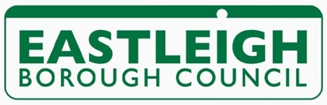

The Summer 2020 Diversification Grant is for businesses registered and trading in the Borough of Eastleigh that have taken risks and shown creativity in adapting to a changing operating environment.

Company Name:
Project Name/idea:

Contact Name: |  | Date:
Address:

Email:
Web address:

Telephone:
Mobile:

Is your organisation registered for VAT? Yes / No

If please give VAT registration number:
Number of years your organisation has been trading:

Number of employees:

Are you currently receiving any funding from any other source? Yes / No
If so, where from:

Is your company registered at Companies House Yes / No

If yes what is your registration number: ……………………………………………………………..
Is your company registered with HM Revenue & Customs? Yes / No

If yes, what is your unique Tax Reference (UTR) number:

Please explain what the grant is going to be used for:

How will this project help your business:

When do you hope this project to be started :
Completed :

Please provide a basic budget for your project showing the estimated costs

Written estimates will be required – please attach

How did you hear about this grant scheme:

We may visit you at your business premises prior to the grants panel.
Please note we will undertake financial checks on your business prior to awarding the grant.

