Eastleigh Borough Council

Spring 2020 Business Grants Application Form
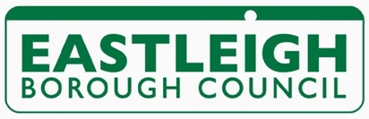

The Business Grant is for businesses registered and trading in the Borough of Eastleigh. The grant available is up to £1000. Deadline for applications is 5pm on Tuesday 31 March. You will be notified the following week if your application has been successful.

Company Name:
Project Name/idea:

Contact Name: |  | Date:
Address:

Email:
Web address:

Telephone:
Mobile:

Is your organisation registered for VAT? Yes / No

If please give VAT registration number:
Number of years your organisation has been trading:

Number of employees:

Are you currently receiving any funding from any other source? Yes / No
If so, where from:

Is your company registered at Companies House Yes / No

If yes what is your registration number: ……………………………………………………………..
Is your company registered with HM Revenue & Customs? Yes / No

If yes, what is your unique Tax Reference (UTR) number:

Please explain what the grant is going to be used for:

How will this project help your business:

When do you hope this project to be started :
Completed :

Please provide a basic budget for your project showing the estimated costs

Written estimates will be required – please attach

How did you hear about this grant scheme:

We may visit you at your business premises prior to the grants panel.
Please note we will undertake financial checks on your business prior to awarding the grant.

