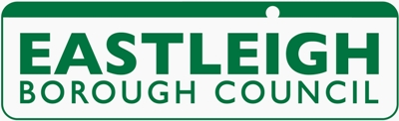
Private Hire Knowledge Test

- This is a 30 minute test taken on a laptop.

- The test covers the Highway Code, Private Hire Law and Premises in the borough.

- The test consists of 30 questions and multiple choice answers.

- The pass mark is Highway Code and law = 26/30

- The cost of each test is £15.00 payable at The Depot in advance of test.

- If you fail the test you may resit a further three times with a two week gap between each test. If you have not passed after 4 attempts, you must wait a further 3 months before you are able to sit the test again.

