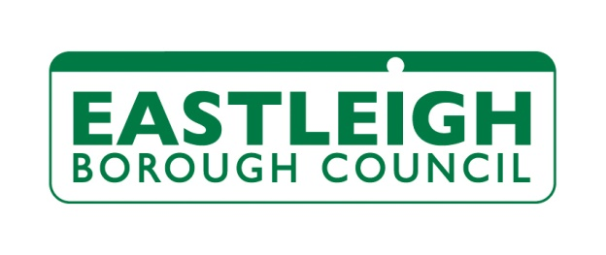

Occupational Therapy Enquiry
Please complete the below form and return it by email to dfg@eastleigh.gov.uk
Date of enquiry:

Name:

Address including post code:

Telephone number(s):

Email address:

Any communication difficulties or preferences?

Date of birth:

What adaptation(s) do you feel would be beneficial? (for example, a stair-lift, level access shower facility):

Are you currently awaiting assessment or having any ongoing support from any health or social care service (e.g. district nurse, community care team, occupational therapist)?

Details of any health issues or disability affecting every-day life (e.g. any difficulties with mobility, steps or stairs, any walking aids used, any difficulties with any activities of daily living):

Any other relevant information:

Eastleigh Borough Council are committed to your privacy. We will use the information on this form in order to contact you to arrange an Occupational Therapy assessment, if one is necessary. The information may then be used to refer you for a grant if adaptations to your home are required. Please refer to our full Privacy Notice at www.eastleigh.gov.uk/privacy

