THE BOROUGH OF EASTLEIGH (HEDGE END, WEST END & BOTLEY)
(AMENDMENT NO. 3) ORDER 2018

NOTICE IS HEREBY GIVEN that the Eastleigh Borough Council pursuant to arrangements made Hampshire County Council proposes to make the above mentioned Traffic Regulation Order in exercise of the powers of the said County Council under Sections 1, 2, 4 of the Road Traffic Regulation Act 1984 (“the Act”) and Part IV of Schedule 9 to the Act, and of all other enabling powers, and after consultation with the Chief Officer of Police in accordance with Part III of Schedule 9 to the Act.

The general effect of the Order will be to:

- The effect will be to insert into The Borough of Eastleigh (Hedge End, West End & Botley) variation Order 2017 new waiting restrictions, as detailed below:

- ‘No Waiting at Any Time’ restrictions in Beattie Rise Hedge End as shown below.

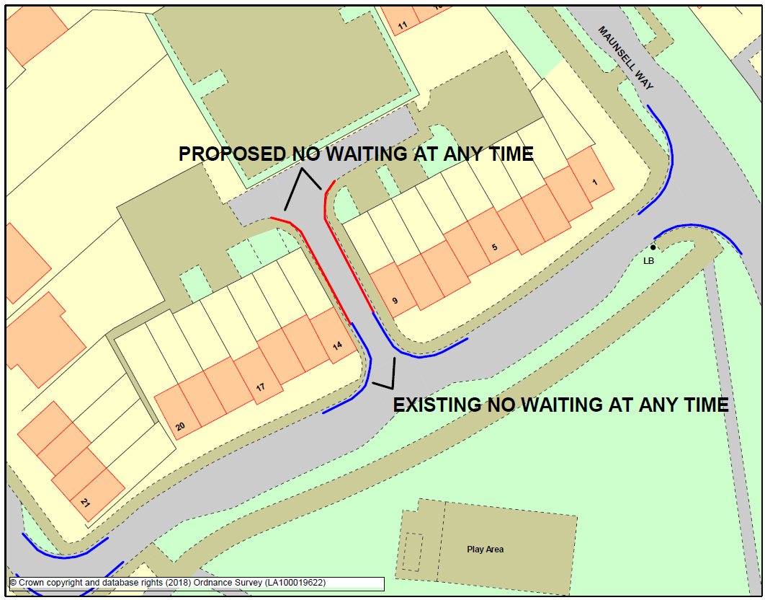

A copy of the Order together with all plans showing the roads to which the Order relates and a statement of the Council’s reasons for proposing to make the Order may be inspected at Eastleigh House, Upper Market Street, Eastleigh during normal office hours or on the Council’s website: www.eastleigh.gov.uk/TRO

Objections to these proposals together with the grounds on which they are made must be sent in writing or via the form on the Councils website to the undersigned by 25 May 2018. Letters of support will also be received during this time.

DATED: 11 May 2018 (Any enquiries please email engineers@eastleigh.gov.uk)

