Landlord portal
What is the landlord portal?
The landlord portal is an online function whereby you can access information about tenants and their Housing Benefit payments. The portal allows you to search for a tenant and access information that may be useful to you.

What information is held on the landlord portal?
- Customers name and address
- A tenants weekly Housing Benefit entitlement
- Past payments and the periods they represent
- Next payment amount
- Ant discretionary housing payment award
- Any Housing Benefit recovery

How do I access the landlord portal?
Visit www.eastleigh .gov.uk

From the landing page you will need to click ‘My Eastleigh’

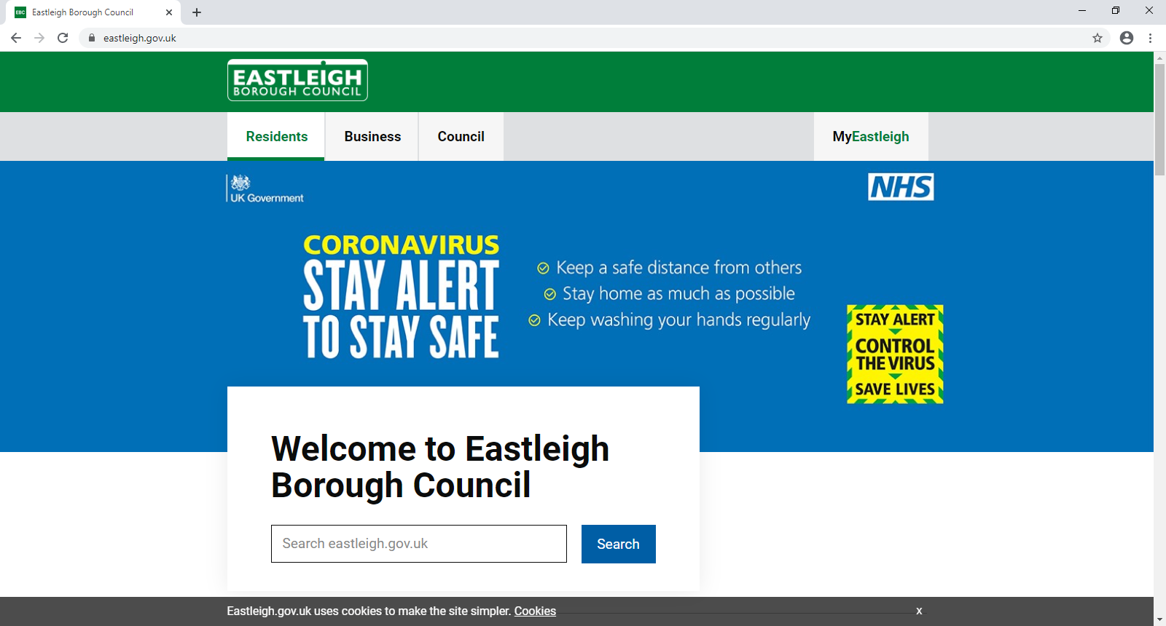

From here click ‘register now’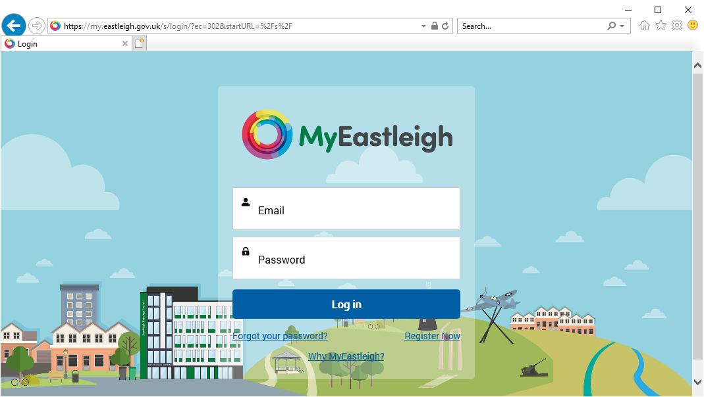

You will then need to enter, your name, as well as an email address and passwords, you may wish to use a generic one for you whole organisation.
Once set up you will need to add your particular account by clicking here
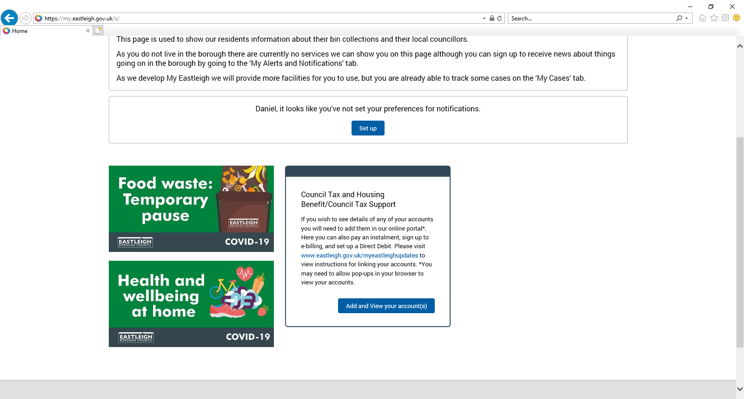

Click ‘add service’
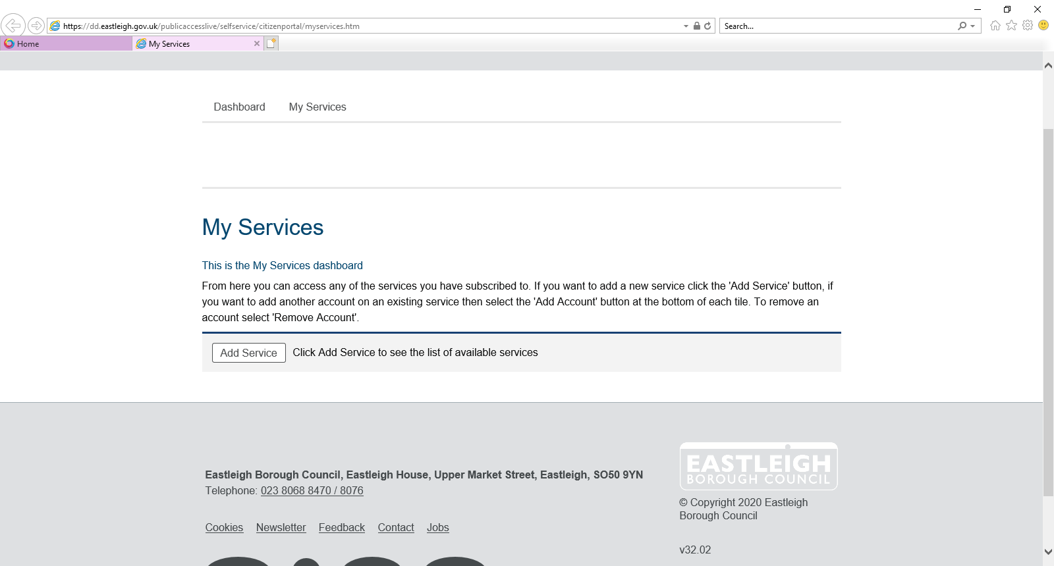
Followed by ‘landlord’
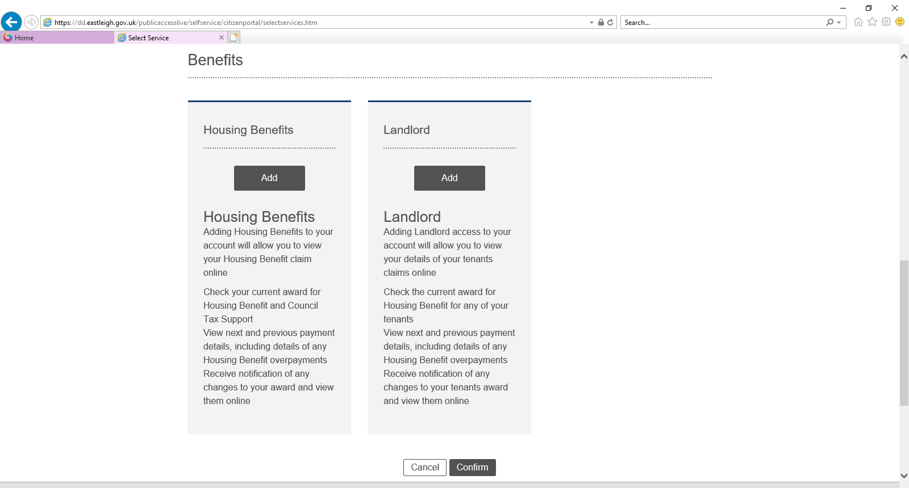

Add your creditor reference (this can be found on any payment schedules)
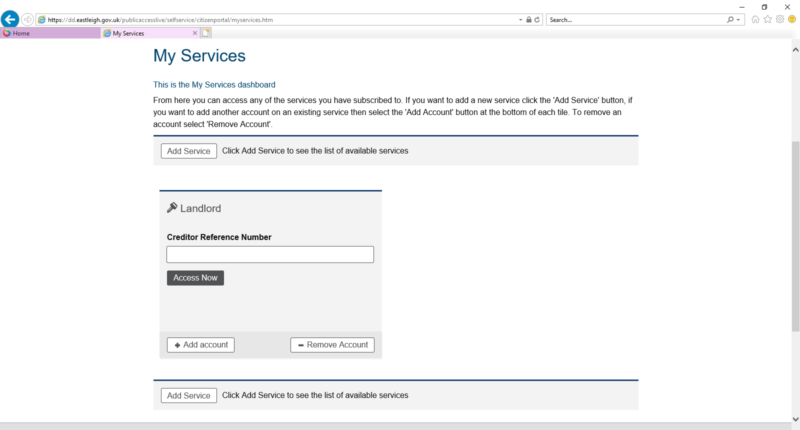

Following this you will be asked a series of landlord specific questions for verification purposes, once answered you will be able to navigate around the portal and view your tenants’ details as above.
Should you experience any difficulties please contact benefits.specialists@eastleigh.gov.uk

